<https://cdn.discordapp.com/attachments/521915027037356052/631684583091470337/unknown.png>

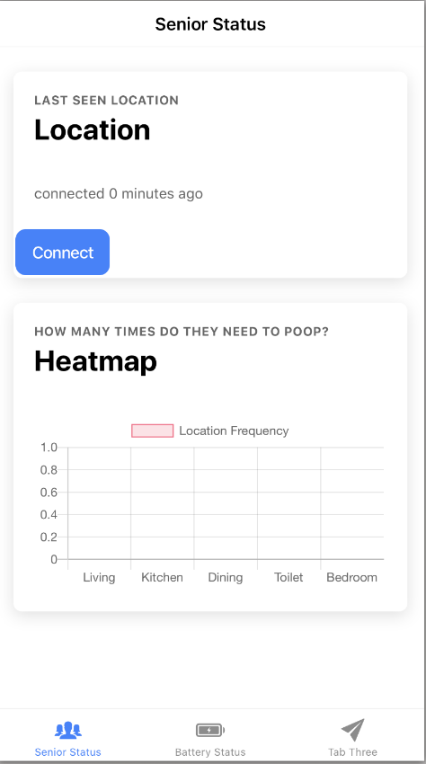

Remote connect to uni Desktop with ssh:

